New Zealand Vintage Kart Register Run at
THE TOP OF THE SOUTH
Radio Nelson Kart Raceway Redwoods Valley Nelson
Herkt Kart Raceway Blenheim

April 16th and 17th The Top of the south played host for the New Zealand Vintage Kart Register’s inaugural trip to the region. With thanks to Mapua’s Frank Davidson for organising both days held at the two tracks. Wet weather greeted all the visitors form Hawkes Bay and Taranaki as well as Auckland in the north island and Christchurch in the south island to join with the local members. 23 karts showed up in the rain, enthusiasium wasn’t dampened too much with all getting a run in the rain at some stage, as usual when every one packed up it cleared and the track dried out!
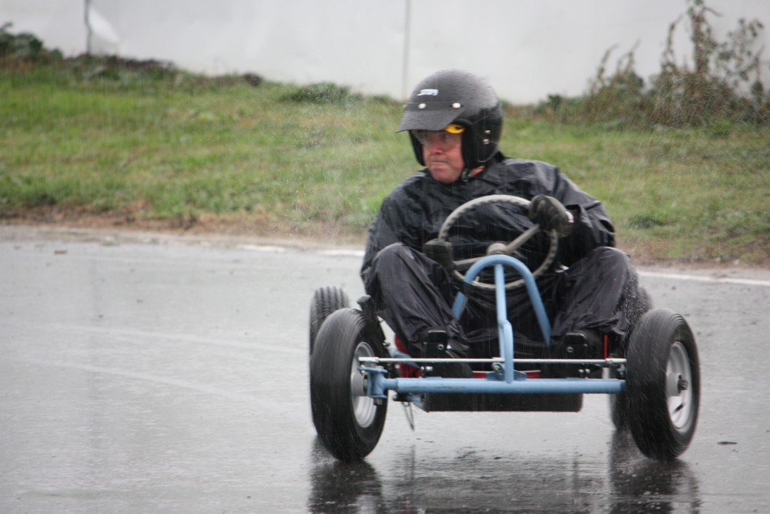
Laurie Callender concentrating hard on his Kall Kart Villiers 197E

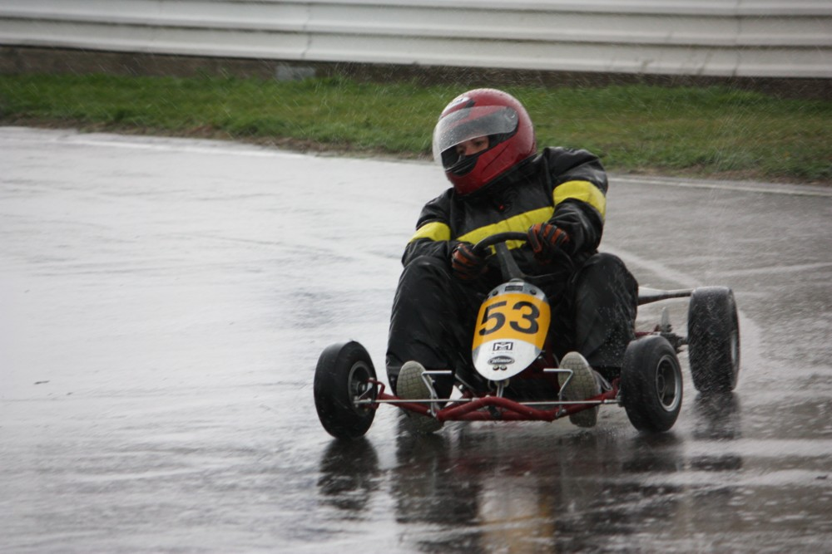
Hawkes Bay’s Sharon Jenkinson, our queen of the wet! Sharon turned more laps in the wet than any other, Dart/McCulloch MC91B/1
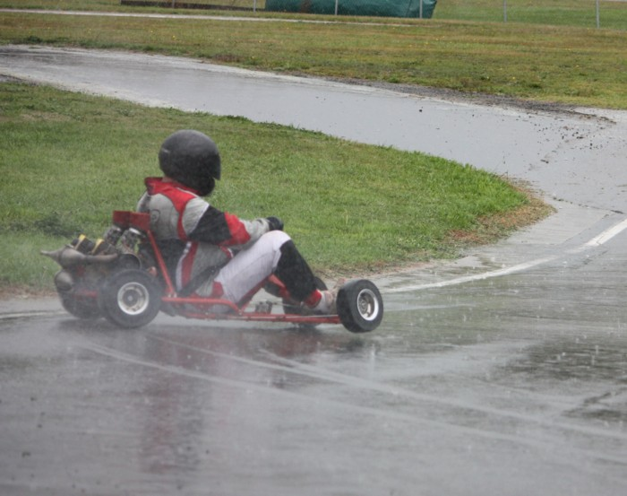
Vintage Kart register photog Phil Davy taking his Dart twin for a spin!!!
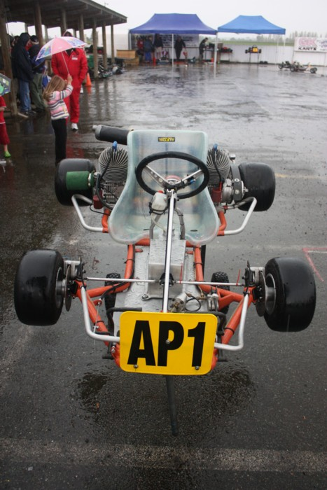
George Hayward showed up with his newly acquired Cobra, actually a new old kart , built in the late 1970’s by Hawkes Bay’s Allan Pithie but never completed with twin Parilla TT22’s. Allan was a NZ manufacturer of Kougar Kart Products, Brakes, Wheels Hubs etc, this kart features Allan’s beautiful craftsmanship.

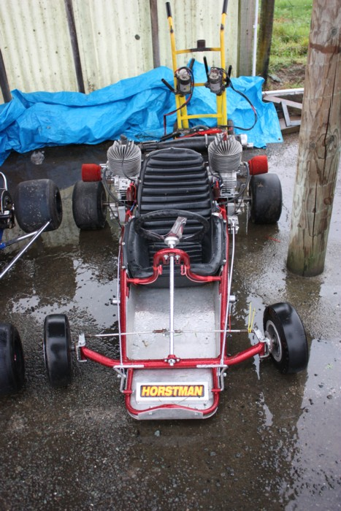
Local vintage karter Frank Davidson’s Hornet with twin DAP T70’s
Frank is the driving force behind vintage karting in the Top of the South region.
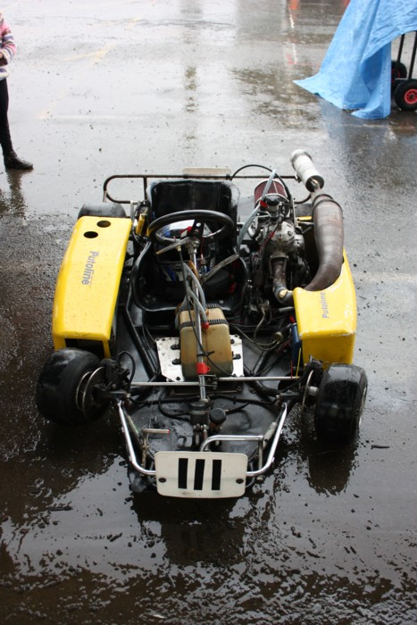
Kerry Radford came up from Christchurch with a pommie Spyder powered with a KTM 250, kart has not seem competition in NZ, was imported with the view to race many years back but it never happened

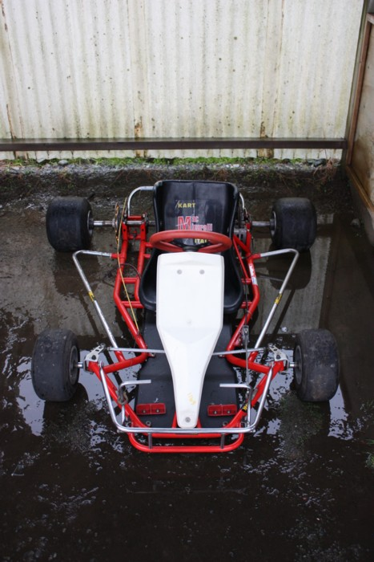
Taranaki kart collector Dean Sutton’s newest acquisition, was delivered from Christchurch to Nelson by George Hayward, a circa 1987 Mac Minarelli, absolutely unmolested, came with a PCR piston port and a Parilla TT25 reed,

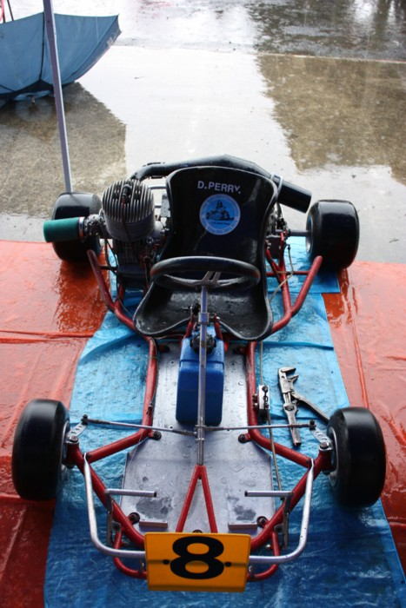
Denis “Honk” Perry’s 1976 BM, with BM 130 engine, Honk raced this in Hong Kong 1976 finishing 9th, in as raced last time at Hong Kong complete with seat sticker form the event!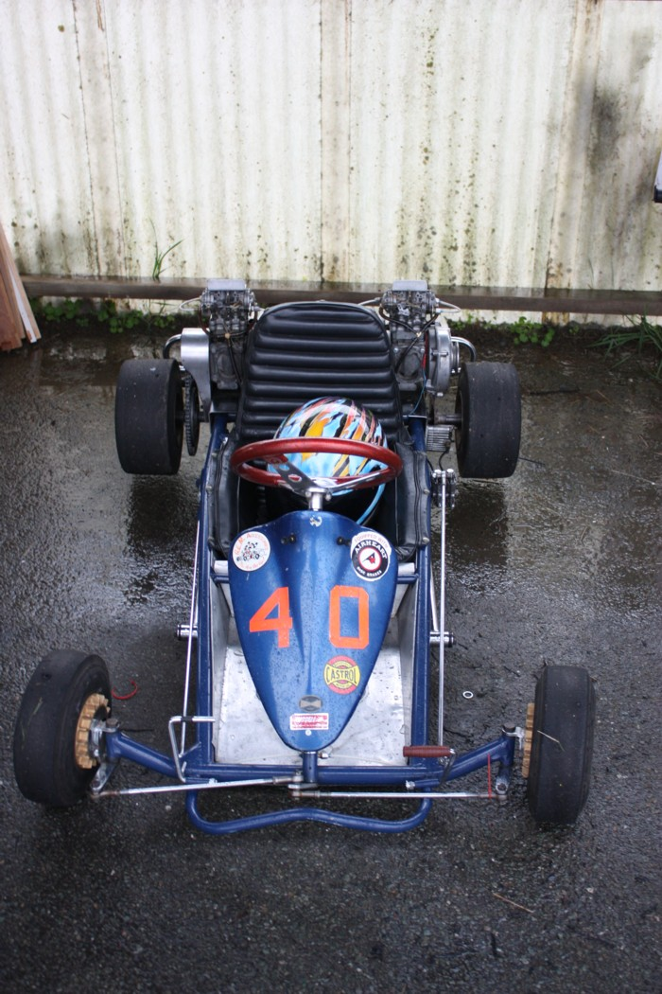
Long time Christchurch karter Robin Wilkinson, showed up with a 1971 Hornet with two McCulloch 101 engines
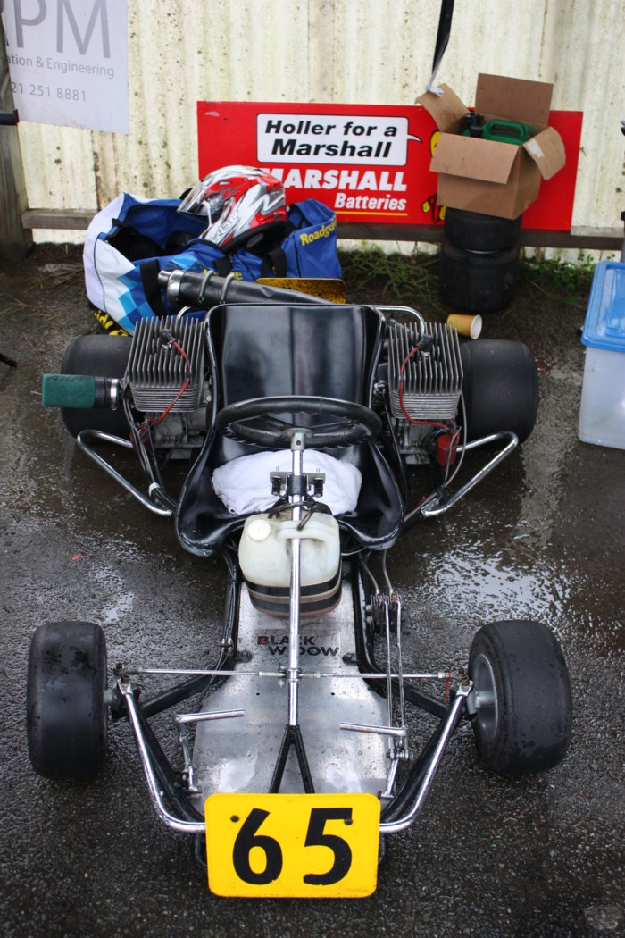
From Christchurch came John Milligan with his Puma twin DAP T80 “Block of Flats” made famous in NZ by Christchurch car dealer Phillip Mills, kart was built by the late Richard Tapper and Chris Lambden at Ian Ballinger Ltd in Christchurch.

On to the second day at Herkt Kart Raceway in Blenheim, and hour’s travel across the hill from Nelson, Vintage Karters where greeted with sun and warmth!

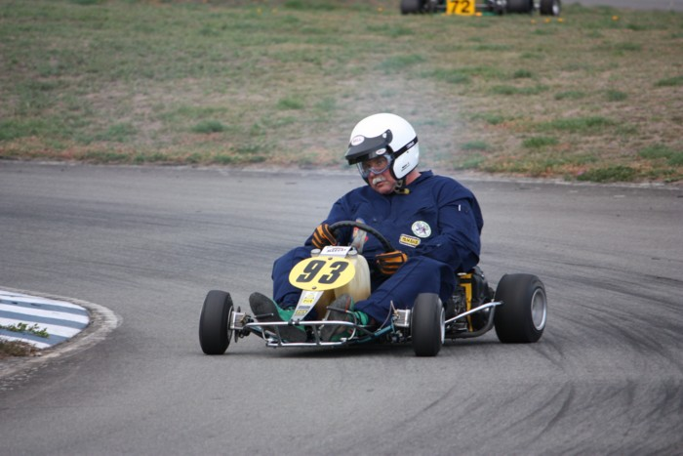
1981 NZ 250cc Kart Champion Mark Jenkinson reverts to his speedway past, sliding around Blenheim with Margay Cheetah twin, a kart that won several major titles in the hands of Levin’s Ian “Snow” Hyndman in the 1970’s

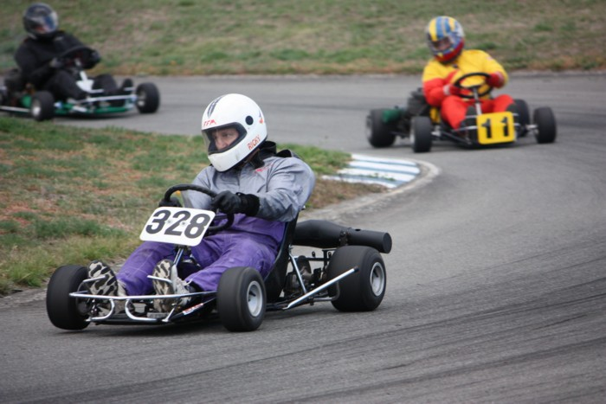
New vintage karting recruit, Motueka’s Ricky Rudolph having a ball in Frank Davidson’s Martin Deluxe, a kart that was manufactured in NZ, Dean Sutton following

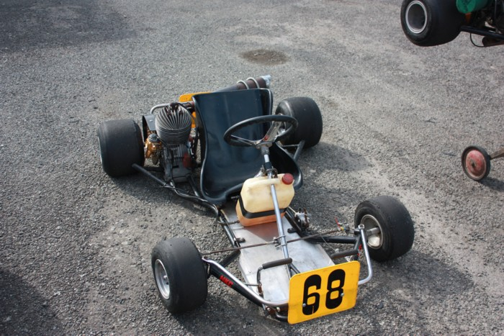
Graeme Sutton form Taranaki bought his NZ built 1976 Puma down to the South Island equipped with a Parilla TT23 with Ibea slide carb.
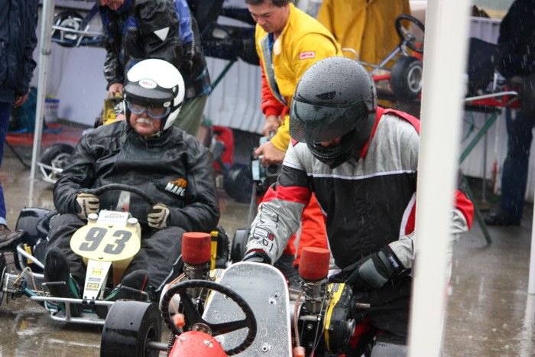
left to right partly obscured Frank Davidson, in yellow Dean Sutton, fire up Mark Jenkinson in his 1973 Margay Cheetah with twin McCulloch MC93’s while Phil Davy readies himself for a spin! Literally
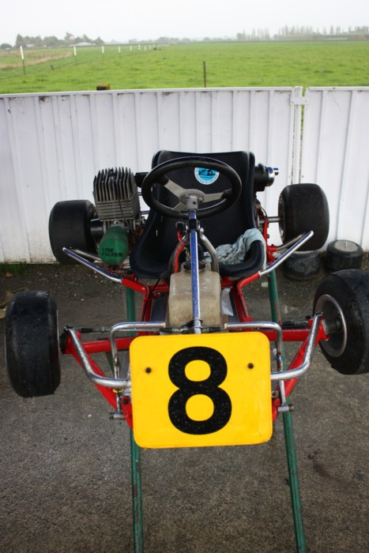
Honk Perry’s 1976 Birel T3 with a PLM reed engine. PLM = Perry Lister Martin, was an attempt to manufacture a NZ built engine to replace the by then out of production McCulloch range, used McCulloch carb and electrics,
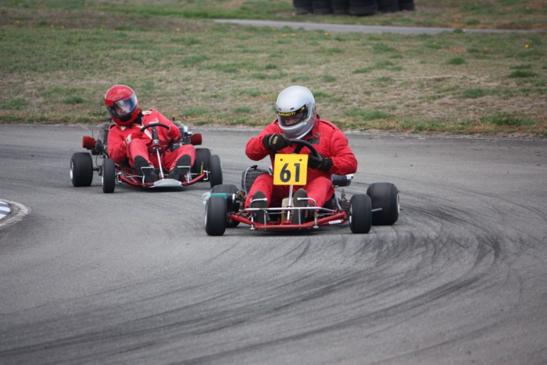
Graeme Sutton sliding around in Phil Davy’s Kiwi Kart FX Pro with Rotax rotary lead’s Stone Brother’s Racing , Ross Hore. Ross was a very successful Nelson karter a few years back, he is driving Frank Davidson’s Hornet twin

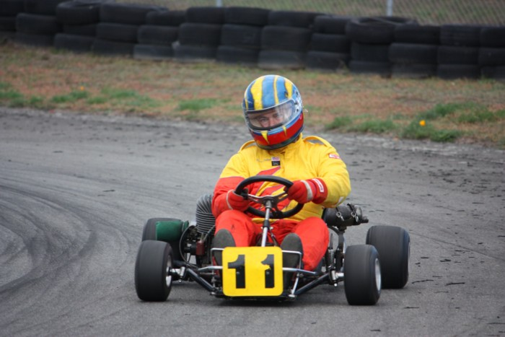
Avid Taranaki Kart Collector Dean Sutton with his SGKC Dominator with PCR 50/3 rotary engine

